Name : Khush Pithva
Subject : Data Structure (2CS501)
Roll no : 24BCE174
---------------------------------------------------------------------------------------------- a. Write a program to create a binary tree and traverse it using the traversal techniques(Preorder, Inorder, Postorder).

Code:
#include <bits/stdc++.h>
using namespace std;

struct Node {
int data;
Node* left;
Node* right;

Node(int val) {
data = val;
left = right = nullptr;
}
};

void insert(Node* root, int val) {
char choice;
cout << "Insert " << val << " to the left or right of " << root->data << "? (L/R): ";
cin >> choice;

if (choice == 'L' || choice == 'l') {
if (root->left == nullptr) {
root->left = new Node(val);
} else {
insert(root->left, val);
}
} else {
if (root->right == nullptr) {
root->right = new Node(val);
} else {
insert(root->right, val);
}
}
}

void preorder(Node* root) {
if (root == nullptr) return;
cout << root->data << " ";
preorder(root->left);
preorder(root->right);
}

void inorder(Node* root) {
if (root == nullptr) return;
inorder(root->left);
cout << root->data << " ";
inorder(root->right);
}

void postorder(Node* root) {
if (root == nullptr) return;
postorder(root->left);
postorder(root->right);
cout << root->data << " ";
}

int main() {
Node* root = nullptr;
int n, val;

if (n <= 0) {
cout << "Tree must have at least one node!" << endl;
return 0;
}
cout << "Enter value for root node: ";
cin >> val;
root = new Node(val);

while (true){
cout << "Enter value for new node: ";
cin >> val;
if(val == -1) break;
insert(root, val);

}

cout << "\nPreorder Traversal: ";
preorder(root);
cout << "\nInorder Traversal: ";
inorder(root);
cout << "\nPostorder Traversal: ";
postorder(root);
cout << endl;
return 0;
}
Output:
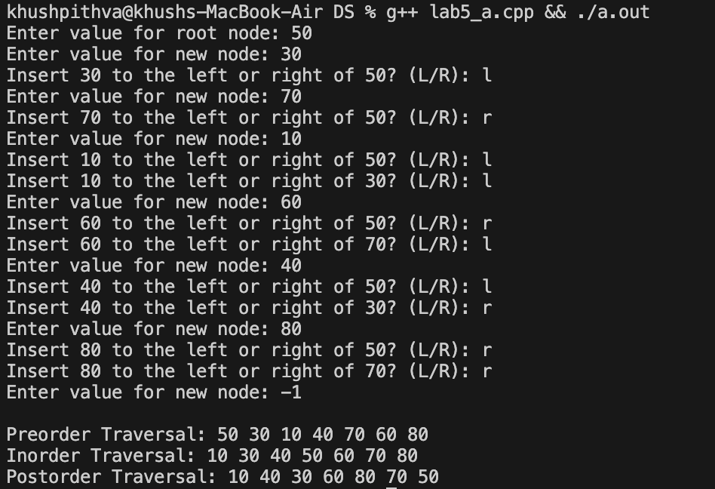
b. Write a program to construct a binary tree from the given preorder and inorder traversal sequence.

Code:
#include <bits/stdc++.h>
using namespace std;

struct Tree
{
int val;
Tree *left;
Tree *right;

Tree() {}
Tree(int val) : val(val) {}
};
void inorder(Tree *root)
{
if (root == NULL)
return;
inorder(root->left);
cout << root->val << " ";
inorder(root->right);
}
void pre_order(Tree *root)
{

if (root == NULL)
return;
cout << root->val << " ";
pre_order(root->left);
pre_order(root->right);
}
void level_order(Tree* root)
{
queue<Tree*> q;
q.push(root);
while(!q.empty())
{
Tree* curr = q.front();
q.pop();
if(curr->left)
q.push(curr->left);
if(curr->right)
q.push(curr->right);
cout << curr->val << " ";
}
cout << endl;
}

int main()
{
int n , x;
cout << "Enter n : ";
cin >> n;

int in[n + 1], pre[n + 1];

cout << "Enter In-order : ";
for (int i = 1; i <= n; i++)
cin >> x , in[x] = i;
cout << "Enter Pre-Order : ";
for (int i = 1; i <= n; i++)
cin >> pre[i];

int id = 1;
function<Tree*( int, int)> ff = [&]( int left, int right) -> Tree*
{
if(left > right)
return NULL;
int curr_root = pre[id];
Tree* root = new Tree(curr_root);
id++;
root->left = ff( left , in[curr_root] - 1 );
root->right = ff( in[curr_root] + 1 , right);
return root;
};
Tree *ROOT = ff(1, n);

cout << "In-order: ";
inorder(ROOT);
cout << endl;
cout << "Pre-order: ";
pre_order(ROOT);
cout << endl;
cout << "Level-order: ";
level_order(ROOT);
/*
inoreder left -- root -- right
preorder root -- left -- right
*/
return 0;
}
Output:
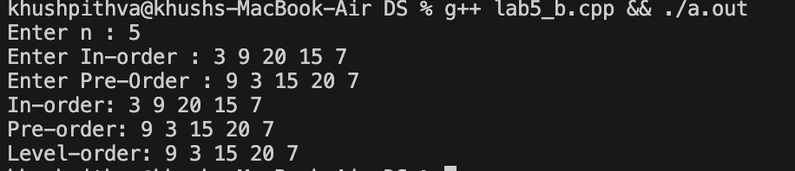

LEETCODE
- Roots equals number of children
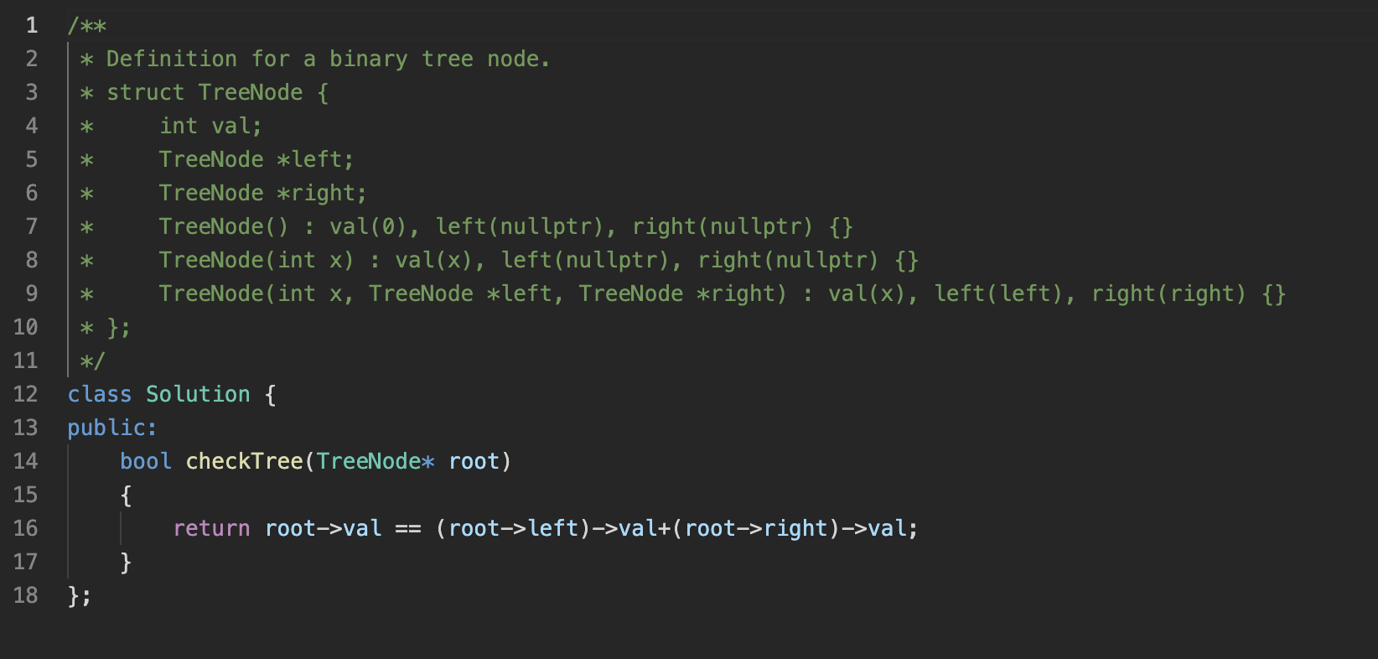
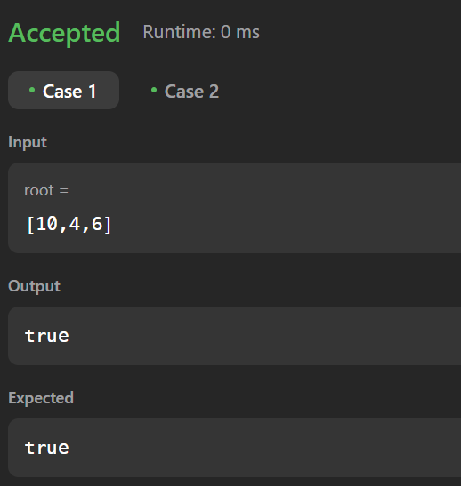

- Count complete tree nodes

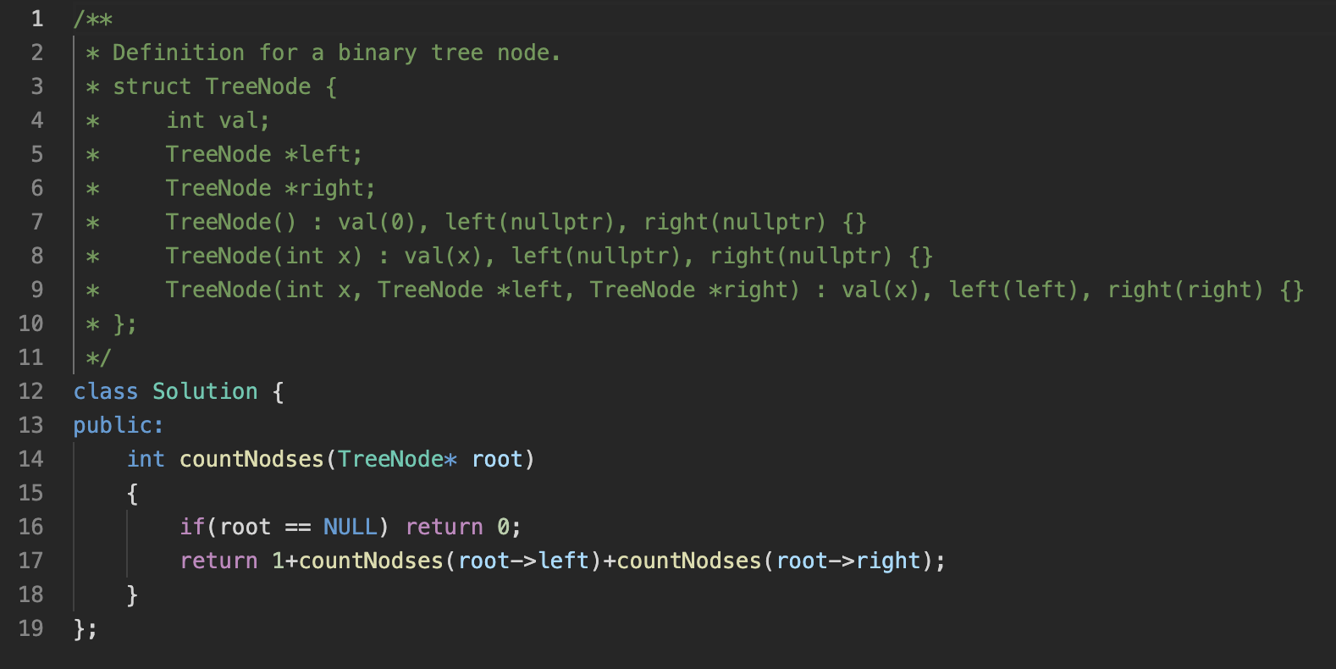
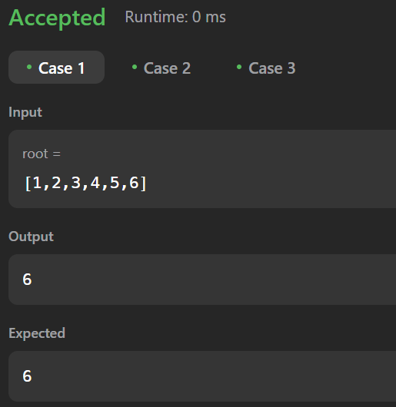

- Flatten binary tree to linked list
